***Fireworks Ordinance***

Fireworks may only be used between 10:00AM-10:00PM except on December 31st, July 3rd and July 4th which the ending hour will be 12:00AM. No person under the age of 18 shall possess, use, ignite or fire or explode any fireworks. You must be 200 ft away from all structures and motor vehicles.

**MEET THE POLICE CHIEF** 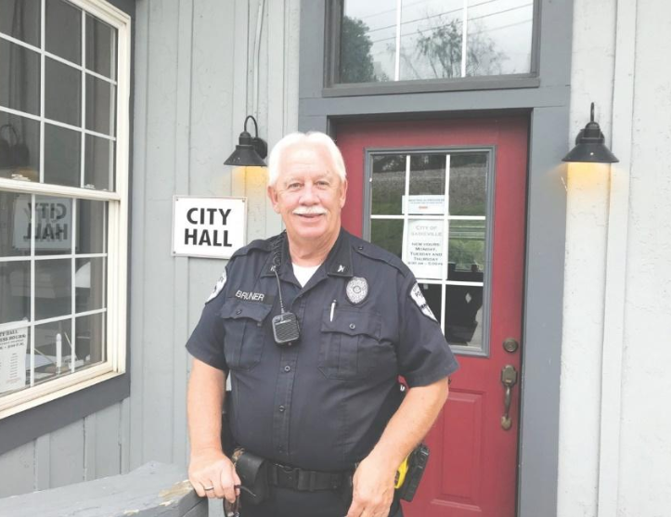

**CHIEF BOBBY BRUNER HAS BEEN WITH THE CITY OF SADIEVILLE SINCE 2005. HE BRINGS A WEALTH OF KNOWLEDGE TO OUR TOWN AS HE HAS OVER 40 YEARS EXPERIENCE IN LAW ENFORCEMENT. HE HAS BEEN WITH THE FAYETTE COUNTY SHERIFFS DEPARTMENT FOR 26 YEARS AND FAYETTE COUNTY SCHOOLS AS A RESOURCE OFFICER FOR 15 YEARS. HE RESIDES IN SCOTT COUNTY WITH HIS WIFE OF 34 YEARS. HE WAS ALSO INVOLVED IN YOUTH SPORTS FOR OVER 30 YEARS AS HE RAISED TWO BOYS WHO PLAYED ALL SPORTS POSSIBLE! HE KNOW HAS 7 GRANDKIDS, 5 GIRLS AND 2 BOYS. CHIEF BRUNER IS HERE TO HELP.**

**Safety Tip from Chief Bruner**

ALWAYS KEEP YOUR VEHICLES LOCKED NIGHT AND TAKE YOUR VALUABLES INSIDE TO PROTECT YOURSELF FROM THEIVES. GET IN THE HABIT OF ALWAYS CHECKING YOUR DOORS BETWEEN 8 AND 9 PM.

VETERANS PARK AND WARRING PAVILION ARE NOW OPEN AND AVAILABLE FOR YOUR RENTAL NEEDS! SCHEDULE YOUR PARTY OR FAMILY REUNION FOR A RESERVATION FEE OF $25, WHICH MUST BE PAID WITHIN TWO WEEKS OF THE EVENT. FOR MORE INFORMATION, CONTACT DEBRA STAMPER AT 502-857-4576. ALCOHOL IS NOT PERMITTED ON ANY PARKS & RECREATION PROPERTY. NO INFLATABLE UNIT MAY BE PLUGGED INTO ANY SHELTER ELECTRIC OUTLET.

1873 – The talk begins, “The Southern Railway may run through the Big Eagle”

1875-Railroad Bridge was being constructed across the Big Eagle – later on to be Sadieville.

1877-Railroad was finished, and the town was born.

In June of 1877 word began to spread of a depot building being constructed and at this time the town of Big Eagle, Sadieville sported a blacksmith shop, carpenter shop, two groceries, one hotel (John Kaley) and seven dwelling houses. Rail cars were running through Sadieville every day and construction of the depot building began. Stock pens were being made and Fairbanks scales were being erected. Property was being bought and sold and the town was progressing. In 1878 (January) a post office was established, J.W. Jones the first postmaster. A livery stable was developed and houses for the watchmen were being built by the Southern Railroad. A telegraph office opened.

In May of 1879, a little less than two years, Sadieville now had two hotels, two large store houses and confectionery shops with beer, fifteen dwelling houses, and two blacksmith shops. In 1880 a new school was started by John A. McCabe and in May of the same year Sadieville was incorporated by T.J. Burgess, Douglas Stewart, T.T. Hedger and John Caley. The first Police Judge was J.W. Truitt and the first Marshall was L. Penn.

**CITY WIDE YARDSALE**

The city wide yard sale was planned for June 6th to coincide with the US 25 sale, but it has been changed it to October 2nd and 3rd. There are spots available for rental at the park. Call city hall for more info.

Remember, there is a leash law in Sadieville. Please always keep your dog secured.

***SADIEVILLE SUNSHINE ***

LIVESTOCK ORDINANCE:

LIVESTOCK MAY BE KEPT WITHIN THE CORPORATE LIMITS OF THE CITY UNDER THE FOLLOWING CONDITION: FOR EVERY ACRE OF AGRICULTURAL LAND, A MAXIMUM OF TWO HEAD OF LIVESTOCK PER ACRE MAY BE KEPT.

Be on the lookout for new street signs that will be installed next week at certain locations!

THE SADIEVILLE IN SEPTEMBER FESTIVAL HAS BEEN CANCELLED TO DUE COVID CONCERNS.

Each residence is responsible for paying and maintaining their own trash removal service through Rumpke. They can be reached at 800-828-8171.

Monthly city meetings are held the 4th Monday of every month at City Hall at 6:00PM. If you cannot make the meeting visit our website to read the meeting minutes.

Mayor’s Minute

Happy Summer, Sadieville...hope this note finds all well...we sharing with you the citizens once more to just bring you up on issues and projects here in our fair city...The commission is in the process of working on a few projects for the summer...they are as follows...painting of city hall, looking at the issue of Vine Street widening and the off street parking for these residence, repairing some things in our park ...repair or replace of a portion of a wall on Main Street that is deteriorating quickly...these are all items that will be before our commission at our regular meeting June 22nd 6pm... City Hall...it will be held outside...possible if weather allows numbers require...Social Distancing and will be observed ....as you see we have a lot before us...wish all well...and stay safe...

REGARDS

MAYOR ROB

Mayor Rob Wagoner

THE CITY OF SADIEVILLE HAS CONTRACTED WITH SEASONS LAWNCARE FOR THE 2020/2021 FISCAL YEAR FOR MOWING AND WEEDEATING. IF YOU SEE JARROD, STOP BY AND SAY HELLO!

June 18, 2020 ISSUE 2

**IMPORTANT CONTACT INFORMATION**

CITY HALL PH (502) 857-4576

POLICE DEPT PH (502) 857-9055

WEBSITE WWW.SADIEVILLEKY.GOV

**FOLLOW “SADIEVILLE HAPPENINGS” ON FACEBOOK**