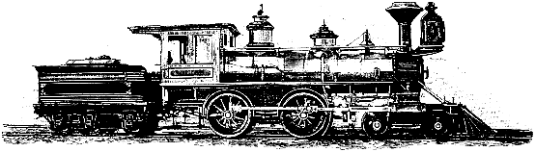

**City of Sadieville**

**P.O. Box 129, 605 Pike Street**

**Sadieville, Kentucky40370**

**Phone: (502) 857-4576; Fax: (502) 857-4555**

**Email:** [**cityhall@sadievilleky.gov**](mailto:cityhall@sadievilleky.gov)

**STATEMENT OF COMPLAINT**

Name of complainant: ______________________________ Phone: _________________

Address: ________________________________________ Email: _________________

Date: ___________________________________________ Time: __________________

Address of Complaint if Applicable: ________________________________________________________

Details of Complaint: _________________________________________________________________________________________________________________________________________________________________________________________________________________________________________________________________________________________________________________________________________________________________________________________________________________________________________________________________________________________________________________________________________________________________________________________________________________________________________________________________________________________________________________________________________________

**City Use ONLY**

Completed By: _________________________________________ Date: __________________________

Commissioner

Plan: ____________________________________________________________________________________________________________________________________________________________________________________________________________________________________________________________________________________________________________________________________________________________________________________________________________________________

Estimated Time Frame of Completion: _____________________________________________________