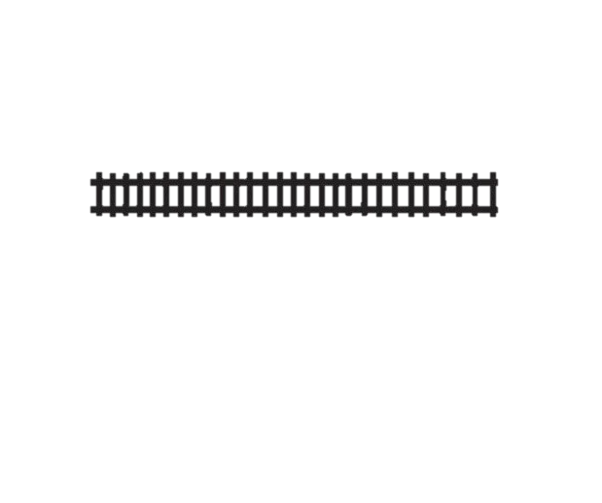****

Project Location: 859 Pike St, Sadieville KY 40370

1. **PURPOSE AND SCOPE:**

The purpose of this request for proposal is to solicit pricing and proposals for the design and build of a water splash pad to be located at Veteran’s Park at the address above.

1. **DESCRIPTION OF SERVICES:**

The following description outlines the scop of work for the project.

Proposer shall include the required points in their proposal:

1. Splash pad shall be confined to a 30x50 area.
2. The owner will provide the necessary power source to the point of connection of the feature.
3. All line sizing must be confirmed with the splash pad product’s manufacturer to insure that the size of the lines and distance are correct for the appropriate flow.
4. System shall have a feature that includes a remote start button and automatic shutoff.
5. Mechanical-Activator Power Post, Controller Potable Water with Surge Protection, 9 Valve Manifold, 12” Drain with 6” Outlet, 3-4” inlet
6. Spray Features- 4 Above Grade, 4 Ground Sprays, Base
7. Shade System - 12x20x8’ Cantilevered Shade with 2 posts
8. **PROJECT SCHEDULE:**

Work is to begin as soon as possible and be completed by May 1, 2023.

1. **PROJECT COORDINATOR**:

Debra Stamper, Parks & Recreation Commissioner

1. **GENERAL REQUIREMENTS:**
2. A current certificate of insurance must be provided with a minimum coverage of $1,000,000 each occurrence, naming the city as the certificate holder.
3. Workers compensation for all employees used on the job pursuant to statute.
4. A business license must be obtained from the City of Sadieville and Scott County.
5. Current W-9.
6. Engineered drawings as required by the Ky Department of Plumbing.
7. All applicable state and local permits.
8. Overall layout plans, descriptions and specifications of project being proposed.
9. Schedule for delivery of equipment and completion of construction must be included.
10. **QUALIFICATIONS:**
11. A statement of experience and qualifications including examples of previous projects.
12. **TIMELINE AND BUSINESS REQUIREMENTS:**

All proposals must be received no later than Monday, August 8, 2022, at 5:00 pm. at Sadieville City Hall, PO Box 129, 605 Pike Street, Sadieville KY 40370.

P.O. BOX 129, 605 PIKE STREET, SADIEVILLE, KY 40370

Phone: (502) 857-4576 Fax: (502) 857-4555

Email: [cityhall@sadievilleky.gov](mailto:cityhall@sadievilleky.gov) Website: [www.sadievilleky.gov](http://www.sadievilleky.gov)