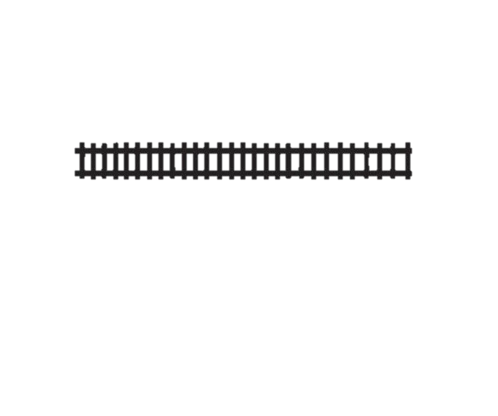****

10/01/2023

Residential Solid Waste Collection and Disposal

The City of Sadieville is accepting bids for 1 x week residential trash pickup to run from January 1, 2024, through December 31, 2024 with the option to renew at the end of the contract. The City contains 140 to 160 homes.

SOLID WASTE DISPOSAL

DEFINITIONS.

For the purpose of this bid the following definitions should apply unless the context clearly indicates or requires a different meaning.

RESIDENTIAL FRANCHISEE. An individual, corporation, partnership or other business association that has been qualified by the city to collect, transport, and dispose of residential solid waste and has executed a commercial and industrial franchise agreement with the city.

RESIDENTIAL FRANCHISE AGREEMENT. A franchise agreement entered into between the city and a franchisee, as the same may from time to time be amended, modified or supplemented in accordance with the terms hereof, including attachments and exhibits.

RESIDENTIAL WASTE. All types of waste generated by residential homes, that is not considered hazardous waste.

RESIDENTIAL FRANCHISE AREA. The city limits of Sadieville, KY.

NON-EXCLUSIVE RIGHT AND SOLICITATION OF BUSINESS.

1. Nonexclusive right. Only the city and individuals or entities which have executed a residential franchise agreement with the city may collect, transport, and dispose of commercial and industrial solid waste within the commercial and industrial franchise area.
2. Solicitation of Business
3. All contracts pertaining to residential waste collection, transport and disposal solicited and/or executed that differ in terms from the provisions of this bid contract are modified by this chapter to the extent of the conflict.

COLLECTION, TRANSPORT, DISPOSAL, EQUIPMENT AND PERSONNEL

1. Collection
2. Each franchisee shall collect residential waste from any resident requesting services without discrimination and shall perform all services in such a manner that complies with all federal, state, and local statutes and regulations pertaining to solid waste collection.
3. Each franchisee shall obtain all necessary federal, state, and local permits to collect waste.
4. Transport
5. Each franchisee shall transport all the residential waste it collects in compliance with all federal, state and local statutes and regulations and in such a manner that prevents the blowing of debris, nor shall the franchisee allow debris, liquid or waste to escape from collection vehicles.
6. Each franchisee shall obtain all necessary federal, state, and local permits to transport waste.
7. Disposal
8. Each franchisee shall dispose of or arrange for disposal of all waste in compliance with all federal, state, and local statutes and regulations.
9. Equipment and Personnel
10. Each franchisee shall have sufficient personnel and shall have on hand at all time and in good working order such equipment and vehicles as to permit the franchisee to adequately and efficiently perform the services required. All equipment shall be kept in good repair, appearance and in a sanitary manner. The vehicles shall be marked appropriately with the name of the franchisee.
11. Each employee shall service the public in a courteous, helpful, and impartial manner. Care shall be taken to prevent damage to any customer’s property including but not limited to containers, buildings, structures and landscaping.
12. Each franchisee shall comply with federal, state and local laws relating to wagers, hours and other applicable laws relating to the employment and protection of employees.

REQUIRED INSURANCE

1. A certificate of liability is required with the City of Sadieville, PO Box 129, Sadieville KY 40370 named as the certificate holder with a $1 million coverage for bodily injury per person, bodily injury per occurrence, property damage per occurrence and property damage aggregate.

P.O. BOX 129, 605 PIKE STREET, SADIEVILLE, KY 40370

Phone: (502) 857-4576 Fax: (502) 857-4555

Email: [cityhall@sadievilleky.gov](mailto:cityhall@sadievilleky.gov) Website: [www.sadievilleky.gov](http://www.sadievilleky.gov)